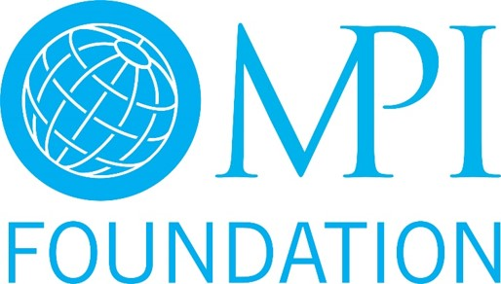
MPI Foundation Scholarship Information
It's the mission of the MPI Foundation to fund education and pan-industry research that drives the success of meeting professionals. This happens most directly through scholarships to MPI members.

Application Cycle
- MPI Foundation scholarships are accepted on an ongoing basis. Applications received by the end of the month will receive notification by the end of the following month.

- Deadlines are set for conference scholarships to ensure enough time is allowed for recipients to arrange travel and accommodations.

- Applicants should take the review process into consideration when applying for funding. When possible, applications for a preferred course should be submitted three months before the course. This allows the committee to review and award scholarships two months prior so the risk of a course being full is reduced. (i.e. If a course takes place in September, the applicant should have their application submitted by the end of June.)

- Qualified applications that are not awarded their first month will be carried over for consideration through the calendar year. Applications will be removed from consideration after the date of the program/event applied for.

SCHOLARSHIPS WITH DEADLINES
Conference scholarships and experiential event scholarships follow the normal application cycle and will be reviewed each month. To allow adequate time for registration and travel arrangements, application deadlines are listed below.

Conference  EMEC 2017, March 5-7, 2017  Applications accepted through November 30, 2016  Notifications by December 31, 2016  IMEX Frankfurt, May 16-18, 2017  Applications accepted November 1, 2016 – January 31, 2017  Notifications by January 31, 2017  WEC 2017, June 19-22, 2017  Applications accepted November 1, 2016 – February 28, 2017  Notifications by February 28, 2017  IMEX America, Oct. 10-12, 2017  Applications accepted May 1 – June 30, 2017  Notifications by July 31, 2017 | Experiential Events  SXSW – March 14 -18  Applications accepted through January 31  Notifications by February 15  Royal Caribbean, May 6-11  Applications accepted through February 28  Notifications by March 31, 2017  C2 Montreal, May 23-25  Applications accepted through February 28  Notifications by March 31, 2017  Indianapolis 500, May 26 – 29  Applications accepted through February 28  Notification by March 31, 2017

SCHOLARSHIP TYPES AND QUALIFICATIONS
Membership Scholarships
- Available for new MPI members.
- Covers the cost of a Preferred MPI membership for one (1) year.
- Designated funds are not available for renewals at this time. If a member needs support in maintaining their membership, they can work directly with their chapter and the MPI Global membership team to discuss alternative solutions.

Professional Development Scholarships
- Only available to current MPI members in good standing.
- Funding available towards all MPI Academy courses (including CMM, HMCC, Experiential Event Series, Meetings Essentials, Basics Boot Camp, and more!)
- Courses can be found online at www.mpiweb.org/MPI-Academy
- Partial and full scholarships awarded.
- Funds awarded will be applied towards registration and program fees.
- Applicants for a CMM scholarship should have already submitted an application to the program. Applicants that have not applied for the CMM program will likely not be considered for funding.
- CMP scholarships are awarded as reimbursements for courses successfully passed within one year from date of passing the exam.

Conference Scholarships
- Only available to current MPI members in good standing.
- Conferences available for funding each year include: WEC, EMEC, IMEX America and IMEX Frankfurt.
- Partial and full scholarships awarded.
- Funds can be applied towards registration fees, airfare, and accommodations, depending on the amount and type of scholarship awarded.
- Conference scholarships are awarded as complimentary registration to MPI events. Additional funding opportunities are awarded as reimbursements after the conference, provided the member has attended the conference.

Academic Scholarships
The MPI Foundation provides academic scholarships for students attending Rosen College at the University of Central Florida and universities in Toronto through sponsored scholarships. Please contact the MPI Foundation to inquire more about these opportunities.

ADDITIONAL INFORMATION
- Preference is given to members that have been an MPI member for at least 1 year for most conference and professional development scholarships. This does not include student member applicants. *Members with less than 1 year will still be considered and should contact the MPI Foundation if they have any questions.

- The number of scholarships available each month varies based on funding and current events/programs taking place.

- Many scholarships supported by a sponsor include restrictions such as member type, geographical location and volunteerism. Scholarships with specific requirements will be listed online.

- Scholarship funds are available for use for up to one (1) year from date of award.

Please contact the MPI Foundation with any questions regarding scholarships and grants.

