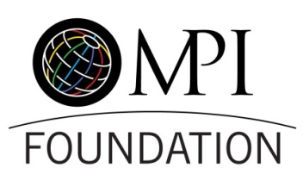

Auction Contribution Form – WEC 2016

This is a personal company/organization donation
Contact Name
Organization / Company
Address
City |  |  |  |  |  | State/Providence
Country |  |  |  |  |  | Zip Code
Phone |  |  |  |  |  | Email

Donated Item(s)/Package: Time sensitive items (hotel stay, gift certificates) be valid at least 1 year from closing date of auction – June 14, 2017

Value: Please list value of each item separately

Description of Items(s): Provide any key descriptions you would like to be included in your donation listing

Restrictions / Expirations Dates: Please list any blackout dates, restrictions and expiration dates for your donated item(s)

Item Delivery
Item(s) enclosed
Item(s) will be mailed to MPI Global (2711 LBJ Frwy., Ste. 600, Dallas, TX 75234)
Item(s) will be sent directly to winner following auction
I will be the point of contact for shipment of the item(s).
A separate individual will coordinate delivery of the item(s).
Name
Phone |  | Email

Certificates: Please complete if your donation includes certificates to redeem any item(s)
It is okay to send electronic versions of certificates via email to winning bidder
Original certificates must be mailed to winning bidder

Images: Please email high resolution (300dpi/1M file size) images for the online catalogue of your item(s)

Please return form to Rachel Schelter at rschelter@mpiweb.org

Terms: Once donated, all items become the property of the MPI Foundation. Gift certificates must be good for a minimum of one (1) year from the date of the auction. The MPI Foundation reserves the right to group items from various donors into bid packages. The MPI Foundation is a tax-exempt 501c (3) organization. All contributions are deductible to the extent allowed by law. The stated value/availability of the donation is the sole responsibility of the donor.

