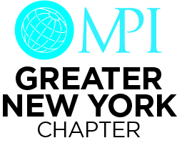
MPIGNY Member Support Fund Application

The purpose of this fund is to provide financial aid to MPI Greater New York members who have been confronted with a catastrophic occurrence. Financial support will be provided in the form of monetary grants to all accepted applicants. This fund is not intended to support payment of membership renewal dues.

For consideration, please complete the below application and submit to our Executive Director, Kathie Stapleton, at kstapleton@mpigny.org.
Please note that all applications will be held in the strictest confidence. All personal details including name, email, company, job title & address will be omitted during the review of each application.

PART ONE

Name:

Preferred Email:

Company:

Job Title:

Address:

Phone Number:

Number of Years as a member of MPIGNY:

Electronic Signature:
I hereby confirm that all the information contained on this application and other submitted documentation is true and correct, under penalty of law.
Full Name & Initials:
Application Date:

PART TWO

- In one paragraph or less, please describe your involvement in the events, meetings, catering or hospitality industry.

- Please explain the circumstances surrounding your request for funds. It is beneficial to provide as many details as possible so that we have a clear understanding of the events leading up to the submission.

- Please state the amount of funds requested along with how the funds will be used. Be as specific as possible. The MPIGNY Application Committee may request supporting documentation if necessary.

Terms & Conditions
- Funds are subject to availability
- MPIGNY Member Support Fund program and review procedures are subject to change
- Monetary grants will not exceed $500.00 per member per calendar year.
- Applications may be denied based on the sole discretion of the MPIGNY Application Committee
- Applicants will be provided a final determination within 72 business hours.

