Global Meetings Industry Day, 2018

New England came together on April 12th, 2018 evening to celebrate Global Meetings Industry Day (GMID) in the true spirit with which the day was created. Through a unique collaboration between the New England chapters of MPI and PCMA, over 270 participants gathered at the Boston Convention & Exposition Center to learn and connect.

Alan Kleinfeld, CMP, LEO of Arrive Conference Solutions delivered a keynote presentation on Event Safety & Security, a well matched subject for this venue and crowd. Being a "Meeting Planner with a Badge" (police badge that is), Kleinfeld emphasized Safety & Security as a mindset and the differences between feeling free from harm and those measures which are taken to prevent harm. New tools to help be more prepared and understand risks can now be implemented for our events, Planners and Suppliers alike. Words to live by...know the location of each marked emergency exit in the room and "exit the building BEFORE tweeting about it".

Our venue host, the BCEC and Levy Catering, put out an amazing display of regional foods. The networking reception enhanced by sponsored table-tops became the focus of the evening. "Fun Facts" on each of our 25 sponsors kept our Planner members engaged and valuable conversations were going on all around. While the appetizers served in sphere shaped containers were really very interesting (not to mention delicious), it was unanimous that the partnership between MPINE and PCMANE is what made tonight special. A joint force to amplify our common voice and love of this industry made this GMID truly memorable.

Here’s the link to photos!

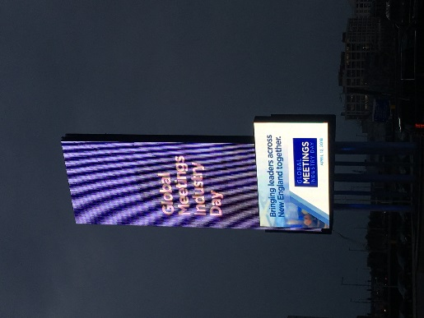 | 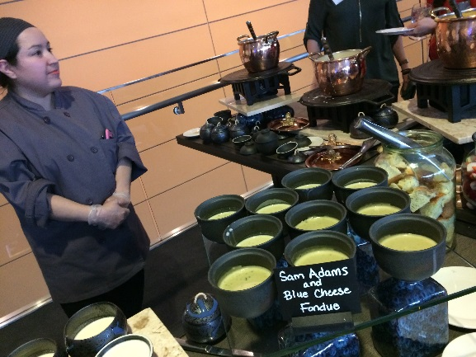 | 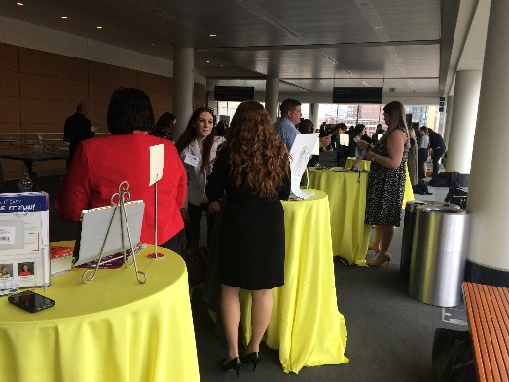
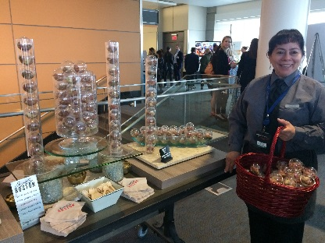 | 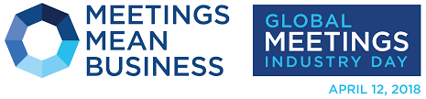 | 