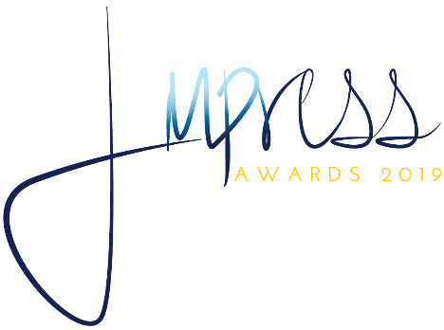

2019 MPI Indiana Chapter Silent Auction Donor Form
26th Annual IMPRESS Dinner and Silent Auction

Please submit this form via email to Denise Wade, dwade@indianacouncil.org. To be included in the Silent Auction digital catalog, this form should be completed and returned by Monday, March 25, 2019. After this date, gifts will be gratefully accepted and listed in catalog updates as time permits. All donations will be distributed at the MPI Indiana IMPRESS Awards on Wednesday, April 24, 2019. Your support of our chapter is greatly appreciated!

Please do not scan; please type your information and answer all questions completely.
Click or tap here to enter text. |  | Click or tap here to enter text.
Donor Company |  | Donor Contact Name
Click or tap here to enter text. |  | Click or tap here to enter text.
Contact Title |  | Address
Click or tap here to enter text. |  | Click or tap here to enter text. |  | Click or tap here to enter text.
City |  | State |  | Zip Code
Click or tap here to enter text. |  | Click or tap here to enter text.
Direct Phone |  | Cell
Click or tap here to enter text. |  | Click or tap here to enter text.
Contact Email |  | Website

Click or tap here to enter text.
Item/Package Title
$Click or tap here to enter text. |  | Click or tap here to enter text.
Full Retail Value |  | Expiration (if other than April 30, 2020)
Click or tap here to enter text.
Blackout Dates (if any)

☐ I will mail my donation. ☐ I will hand-deliver my donation (delivery date: Click or tap here to enter text. )
(Select One)
Describe your donation and your company/service. List any restrictions or the donation will be considered unlimited.
Click or tap here to enter text.

Mailing your donation?
Please send to: Laura Kenny, CMP - Sales Manager, Indiana Convention Center, 100 S Capitol Ave, Indianapolis, IN 46225

Items should be labeled “MPI INDIANA SILENT AUCTION”, and we ask that they are received no later than Friday, April 19th. Laura can be reached at 317/262-3408 with any questions regarding shipping or dropping off items.

