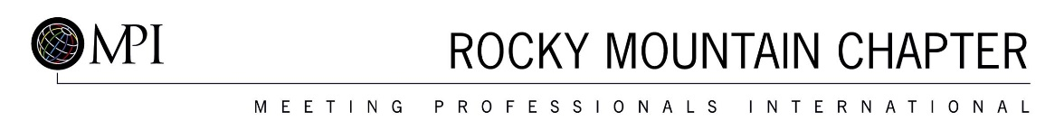

Request for Proposal for
Meeting Professionals International Rocky Mountain Chapter
Printed Directory

Deadline for submission is March 22, 2019

The Rocky Mountain Chapter (MPIRMC) is an affiliate of Meeting Professionals International (MPI), the meeting and event industry's largest and most vibrant global community with 18,000+ members in belonging to 71 countries and 70 chapters and clubs worldwide. The MPI Rocky Mountain Chapter was the first chapter recognized in 1973 and strives to continue to be the leader in the industry. The Rocky Mountain Chapter was recognized as Chapter of the Year in 2006.

MPI’s Vision
To be the first choice for professional career development and a prominent voice for the global meeting and event community.

MPI’s Mission
To provide MPI members, chapters and the global meeting and event community with innovative and relevant education, networking opportunities and business exchanges, and to act as a prominent voice for the promotion and growth of the industry.

Service Required
MPIRMC publishes a bi-annual membership guide and directory. We require a graphic designer to create the booklet cover and layout the contents that are provided, including inserting advertising that we sell. In addition, we require printing overview and management to booklet completion.

Printing Specs
500 - 6x9 spiral bound booklets.
Cover and 3 tabbed sheets
100# gloss cover printed 4/4.
Guts 84 pages 5.5 x 8.5
80# gloss text printed black/black.

Dates of proposed services
- April 1- 12, 2019 – formatting of booklet
- April 15- 19, 2019 – Proofing
- April 22- 26, 2019 - Printing

Please respond with a complete proposal to Nicole Nguyen dirofpublications@gmail.com Address questions by email only.

