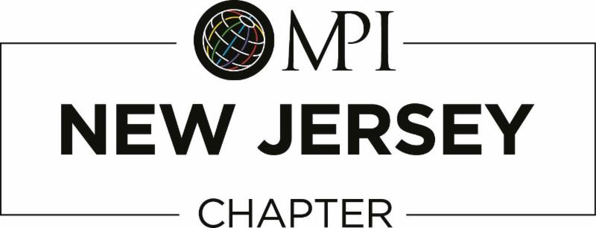

MPI New Jersey Chapter Affiliate Membership Application 2017

Affiliate Membership is open to any MPI member in good standing. As an affiliate member of the New Jersey Chapter, you will receive the following:

- MPI New Jersey Chapter event announcements and registration at the member rate.
- Member rate on sponsor packages and advertising.

The annual fee for MPI New Jersey Affiliate Membership is $99.00.
Email this application to: heatherkresge@outlook.com

Name: Click or tap here to enter text.
Title: Click or tap here to enter text.
MPI Member ID Number: Click or tap here to enter text.
Member Type: Choose an item.
Company: Click or tap here to enter text.
Mailing Address: Click or tap here to enter text.
Business Phone: Click or tap here to enter text.
Email: Click or tap here to enter text.

Payment Process: When we receive your completed application, MPI New Jersey will email you an invoice that you can pay securely on line with any credit card or you can mail a check to the address on the invoice. Once we receive your payment, you will be added to the MPI-NJ roster as an affiliate member.

Thank you for your application and support of MPI-NJ Chapter. We look forward to having you as a member.
For MPI-NJ Office Use Only
Processed By and Date__________________________________________________

