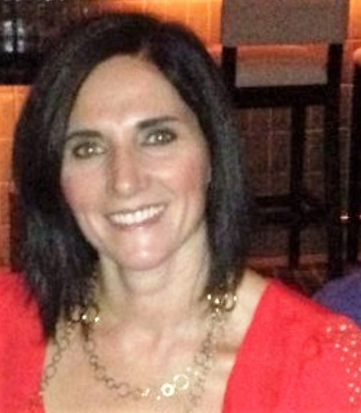
Name: Donna Vitale-Schwartz
Occupation: National Sales Manager
Planner or Supplier: Supplier
Current Employer: Caesars Entertainment

How did you get your start in the industry?
Born and raised in the restaurant business.

How many years have you been in the industry?
Over 30….

What is your favorite thing about our industry?
Building relationships with colleague and clients that last beyond the contract.

What is the best career advice you’ve received?
That things always work out.

If you were not in this industry, what would you be doing right now?
Baking cookies and making chocolates!

Where did you grow up?
The Jersey Shore of Monmouth and Ocean Counties

What is your favorite city to travel to and why?
Italy…the history and architecture.

What is your all-time favorite movie?
Casablanca

How long have you been a member of MPI?
At least 20 years…

What do you love about MPI New Jersey Chapter?
Networking with colleagues and meeting new people from all industries and backgrounds.

