HOSTED BUYER PROGRAM
(SUPPLIER)

A designated time for suppliers and qualified planners to meet one-on-one
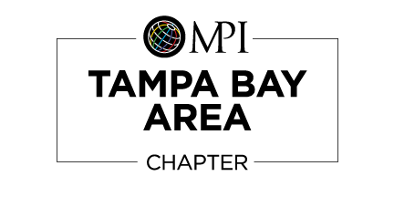
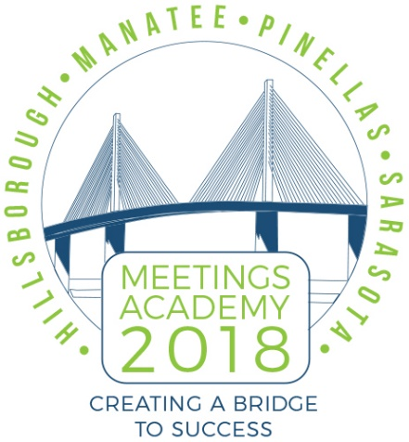
April 18 -19, 2018, Westin Sarasota

We know how valuable your products and services are and you know that your industry's best customers would agree - if you could only spend quality time to make your case. At the 2018 MPI Tampa Bay Area Meetings Academy, you can meet with qualified planners one-on-one.
At Meetings Academy 2018, you'll have pre-scheduled, one-on-one meetings with the best target prospects. You’ll have the time to uncover opportunities, overcome objections and build the relationships you're looking for.
Participating in 2018 Meetings Academy Hosted Buyer Program in Sarasota, Florida allows you to meet face-to-face with qualified suppliers and solidify your future meetings business in an intimate environment.
Face-to-face meetings with qualified business professionals comes with the following benefits:
- Up to 11 face-to-face 7 minute appointments
- Prime exposure within the 2018 Meetings Academy throughout the conference
- One complimentary Meetings Academy registration; Includes access to all conference education and breakout sessions
- One Table and 2 chairs at the Hosted Buyer Program
- 2 Meet and greet receptions with event attendees
- Networking lunch with attendees
- Exhibit space (on cocktail round) following the hosted buyer program - only used to display promotional items
- COST: $550.00

Join the Hosted Buyer Program as an exclusive supplier and get business done!
Please print, complete and submit.

PARTICIPANT INFORMATION:
Full Name:
Title:
Company Email:
Cell Phone Number:

COMPANY INFORMATION:
Company Name:
Address:
City: State: Zip:
Country:
Company Phone Number:
Website:
MPI Chapter:
Chapter Referral:

Industry Type:
(Association, Corporate, Non-Profit etc.)

Services/products you provide:
Advertising & Promotional Services Airline
Association Computer Services
Conference & Convention Center Convention & Visitors Bureau
Cruise Line Decorator
Destination Management Company Destinations
Entertainment Agency Hotels
Full-Service Event Management Company Resorts & Spas
Technology Company Other Suppliers & Service Provider
Photography Production Company
Promotional Merchandiser Rental Car Company
Restaurants Speaker Bureaus

Max attendees can you accommodate:

Destinations you provide your services:
Alaska
Hawaii
Midwest (IL,IN,OH,MI,MN,WI,IA,MO,KS,OK,NE,SD,ND)
Mountain (UT,CO,WY,MT)
Northeast (ME,NH,VT,MA,RI,CT,NY,NJ,PA,DE,MD)
Northwest (WA,OR,ID)
Puerto Rico/Virgin Islands
Southeast (FL,GA,SC,NC,LA,AL,MS,AR,TN,KY,WV,VA,DC)
Southwest (CA,NV,AZ,NM,TX)
International

Would you like to add any additional comments? (Optional)

Terms & Conditions

- Suppliers agree to meet with participating planners over a span of one (1) day during the Hosted Buyer Program. The supplier agrees to attend the minimum appointments included in the supplier chosen.
- Your credit card will be processed and charged a $550.00 U.S. deposit at the time of registration.
- Suppliers who no-show for one or more appointments will be charged for gratis benefits received according to the planner package. This will be:
  - A full conference badge ($79.00-$139.00), Luncheon, Breakout Sessions and Networking Event.
- Acceptance into the Hosted Buyer Program is non-transferrable.
- Cancellation: From time of acceptance notification and prior to February 15, 2018, cancellation must be received in writing and you will be refunded 50% of your deposit. After February 15, 2018, your entire deposit is non-refundable.
- Any hotel cancellation fees, incidental expenses, and additional room nights will be the responsibility of the supplier.
- There are no acceptable reasons for missing the official Hosted Buyer Program time frames.
- All supplier participants must be checked in at the registration desk in the conference center by 8:30am (EST) on Thursday, April 19, 2018 (NO EXCEPTIONS).
- After the conference, all participants are asked to fill out the Hosted Buyer Program survey. Any feedback or quotes may be used in future program material.
- All suppliers must provide an on-site cell phone that they can be reached at during the event (NO EXCEPTIONS).

I have read the above terms & conditions for the MPI Tampa Bay Chapter 2018 Meetings Academy and agree to all terms & conditions:

Name:

Signature (By Printing my initials, I am signing this document:

Please send this completed document to Jennifer L.Smith, CMP, 2018 Meetings Academy Chair, at jlsmith2017@outlook.com.

